**REACT**

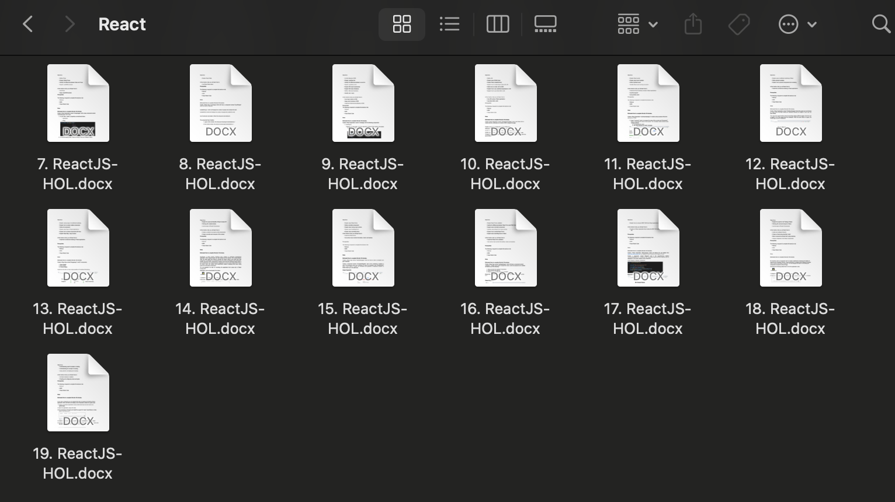

**Hands-On 7**

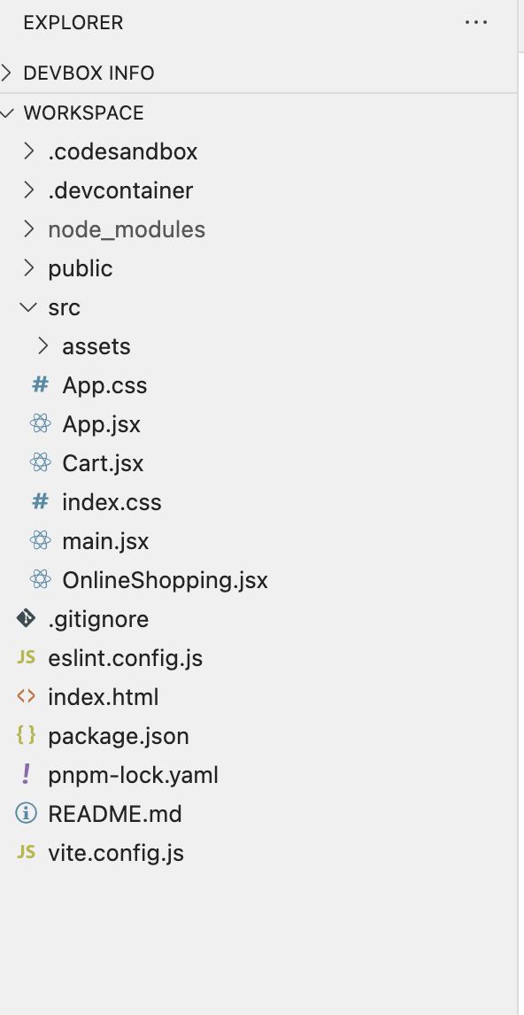

**OnlineShopping.jsx:**

import React from "react";

import { Cart } from "./Cart";

export class OnlineShopping extends React.Component {

render() {

const CartInfo = [

{ itemname: "Laptop", price: 80000 },

{ itemname: "TV", price: 120000 },

{ itemname: "Washing Machine", price: 50000 },

{ itemname: "Mobile", price: 30000 },

{ itemname: "Fridge", price: 70000 },

];

return (

<div className="mydiv">

<h1>Items Ordered:</h1>

<Cart item={CartInfo} />

</div>

);

}

}

**Cart.jsx:**

import React from "react";

export class Cart extends React.Component {

render() {

return (

<table border="1" cellPadding="10">

<thead>

<tr>

<th>Item Name</th>

<th>Price (₹)</th>

</tr>

</thead>

<tbody>

{this.props.item.map((item, index) => (

<tr key={index}>

<td>{item.itemname}</td>

<td>{item.price}</td>

</tr>

))}

</tbody>

</table>

);

}

}

App.jsx:

import React from "react";

import { OnlineShopping } from "./OnlineShopping";

function App() {

return (

<div>

<OnlineShopping />

</div>

);

}

export default App;

Output:

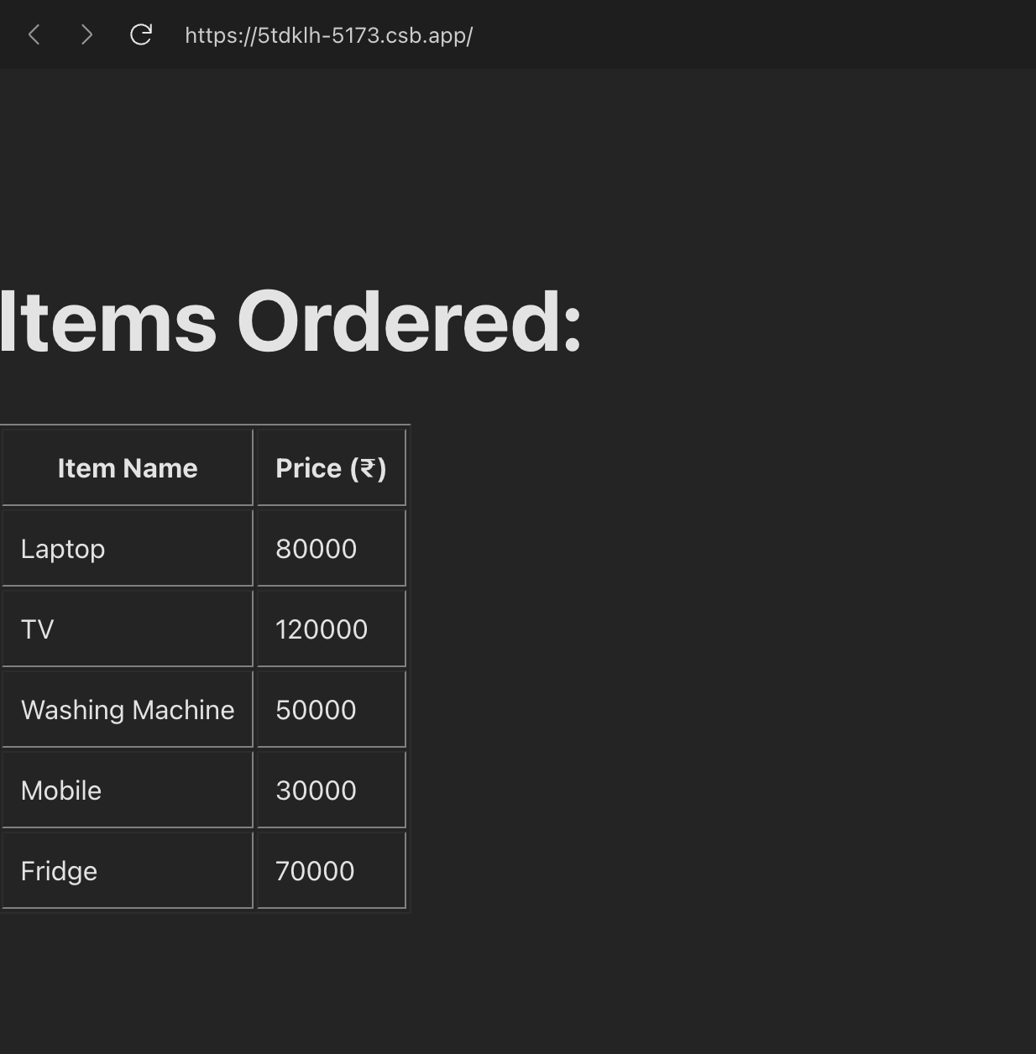

**Hands-On 8**

**CountPeople.jsx:**

import React from "react";

export class CountPeople extends React.Component {

constructor() {

super();

this.state = {

entrycount: 0,

exitcount: 0,

};

}

updateEntry = () => {

this.setState((prevState) => ({

entrycount: prevState.entrycount + 1,

}));

};

updateExit = () => {

this.setState((prevState) => ({

exitcount: prevState.exitcount + 1,

}));

};

render() {

return (

<div style={{ textAlign: "center", marginTop: "50px" }}>

<h1>Mall Entry Tracker</h1>

<p>People Entered: {this.state.entrycount}</p>

<p>People Exited: {this.state.exitcount}</p>

<button onClick={this.updateEntry}>Login</button>

<button onClick={this.updateExit} style={{ marginLeft: "10px" }}>

Exit

</button>

</div>

);

}

}

**App.jsx:**

import React from "react";

import { CountPeople } from "./CountPeople";

export default function App() {

return (

<div className="App">

<CountPeople />

</div>

);

}

**Output:**

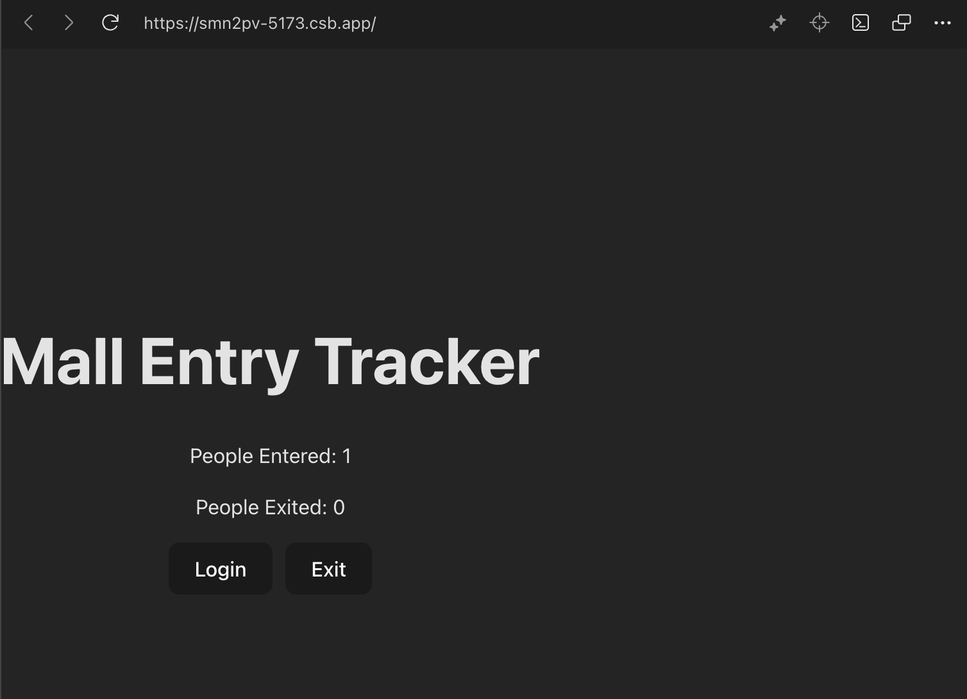

**Hands-On 9**

**IndianPlayers.jsx:**

import React from "react";

export function OddPlayers([first, , third, , fifth]) {

return (

<div>

<h3>Odd Team Players</h3>

<ul>

<li>First: {first}</li>

<li>Third: {third}</li>

<li>Fifth: {fifth}</li>

</ul>

</div>

);

}

export function EvenPlayers([, second, , fourth, , sixth]) {

return (

<div>

<h3>Even Team Players</h3>

<ul>

<li>Second: {second}</li>

<li>Fourth: {fourth}</li>

<li>Sixth: {sixth}</li>

</ul>

</div>

);

}

function IndianPlayers() {

const T20Players = ["Virat", "Rohit", "Hardik"];

const RanjiTrophyPlayers = ["Pujara", "Rahane", "Saha"];

const allPlayers = [...T20Players, ...RanjiTrophyPlayers];

return (

<div>

<h2>Merged Indian Players</h2>

<ul>

{allPlayers.map((player, index) => (

<li key={index}>{player}</li>

))}

</ul>

<OddPlayers {...[allPlayers]} />

<EvenPlayers {...[allPlayers]} />

</div>

);

}

export default IndianPlayers;

**ListOfPlayers.jsx:**

import React from "react";

function ListofPlayers() {

const players = [

{ name: "Jack", score: 50 },

{ name: "Michael", score: 70 },

{ name: "John", score: 40 },

{ name: "Ann", score: 61 },

{ name: "Elisabeth", score: 61 },

{ name: "Sachin", score: 95 },

{ name: "Dhoni", score: 100 },

{ name: "Virat", score: 84 },

{ name: "Jadeja", score: 64 },

{ name: "Raina", score: 75 },

{ name: "Rohit", score: 80 },

];

const playersBelow70 = players.filter((player) => player.score <= 70);

return (

<div>

<h2>List of Players</h2>

<ul>

{players.map((player, index) => (

<li key={index}>

Mr. {player.name} <span>{player.score}</span>

</li>

))}

</ul>

<h2>List of Players having Scores Less than 70</h2>

<ul>

{playersBelow70.map((player, index) => (

<li key={index}>

Mr. {player.name} <span>{player.score}</span>

</li>

))}

</ul>

</div>

);

}

export default ListofPlayers;

**App.jsx:**

import React from "react";

import ListofPlayers from "./ListofPlayers";

import IndianPlayers from "./IndianPlayers";

function App() {

const flag = true; // Change this to false to test IndianPlayers

return (

<div className="App">

<h1>Cricket App</h1>

{flag ? <ListofPlayers /> : <IndianPlayers />}

</div>

);

}

export default App;

Output:

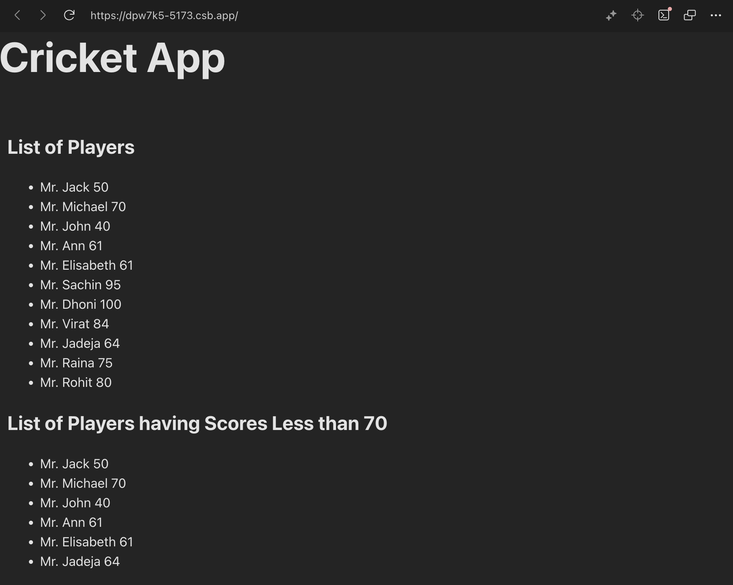

**Hands-On 10**

**App.jsx:**

import React from "react";

import "./App.css";

import officeImage from "./office.jpg";

function App() {

const heading = "Office Space";

const jsxImage = (

<img

src={officeImage}

width="30%"

height="30%"

alt="Office Space"

style={{ borderRadius: "10px" }}

/>

);

const officeItem = {

Name: "DBS",

Rent: 50000,

Address: "Chennai",

};

const officeList = [

{ Name: "WeWork", Rent: 75000, Address: "Bangalore" },

{ Name: "Regus", Rent: 58000, Address: "Pune" },

{ Name: "Innov8", Rent: 62000, Address: "Hyderabad" },

{ Name: "SmartSpace", Rent: 45000, Address: "Kolkata" },

];

const getRentColor = (rent) => {

return rent <= 60000 ? "textRed" : "textGreen";

};

return (

<div className="App">

<h1>{heading}, at Affordable Range</h1>

{jsxImage}

<h3>Name: {officeItem.Name}</h3>

<h3 className={getRentColor(officeItem.Rent)}>

Rent: ₹{officeItem.Rent}

</h3>

<h3>Address: {officeItem.Address}</h3>

<h2>Office Listings</h2>

<ul>

{officeList.map((item, index) => (

<li key={index}>

<strong>{item.Name}</strong> -

<span className={getRentColor(item.Rent)}> ₹{item.Rent} </span> -

{item.Address}

</li>

))}

</ul>

</div>

);

}

export default App;

**App.css:**

.App {

font-family: Arial, sans-serif;

text-align: center;

padding: 20px;

}

.textRed {

color: red;

font-weight: bold;

}

.textGreen {

color: green;

font-weight: bold;

}

ul {

list-style: none;

padding: 0;

}

**Output:**



**Hands-On 11**

**App.jsx:**

import React, { Component } from "react";

import "./App.css";

class CurrencyConverter extends Component {

constructor(props) {

super(props);

this.state = {

rupees: "",

euro: "",

};

}

handleInputChange = (e) => {

this.setState({ rupees: e.target.value });

};

handleSubmit = (e) => {

e.preventDefault();

const rupees = parseFloat(this.state.rupees);

const euro = (rupees / 90).toFixed(2);

this.setState({ euro });

};

render() {

return (

<div className="converter">

<h2 className="green-heading">Currency Converter</h2>

<div className="form-row">

<label>Amount:</label>

<input

type="number"

placeholder="Enter amount"

value={this.state.rupees}

onChange={this.handleInputChange}

/>

</div>

<div className="form-row">

<label>Currency:</label>

<input type="text" value="EURO" readOnly />

</div>

<button className="submit-btn" onClick={this.handleSubmit}>

Submit

</button>

{this.state.euro && <p>Converted: €{this.state.euro}</p>}

</div>

);

}

}

class App extends Component {

constructor(props) {

super(props);

this.state = {

count: 0,

};

}

increment = () => {

this.setState((prevState) => ({ count: prevState.count + 1 }));

this.sayHello();

};

sayHello = () => {

console.log("Hello! Static Message.");

};

decrement = () => {

this.setState((prevState) => ({ count: prevState.count - 1 }));

};

sayWelcome = (msg) => {

alert(msg);

};

onPress = (event) => {

alert("I was clicked!");

};

render() {

return (

<div className="App">

<div className="button-column">

<button onClick={this.increment}>Increment</button>

<button onClick={this.decrement}>Decrement</button>

<button onClick={() => this.sayWelcome("Welcome!")}>

Say Welcome

</button>

<button onClick={this.onPress}>Synthetic OnPress</button>

</div>

<CurrencyConverter />

</div>

);

}

}

export default App;

**App.css:**

.App {

font-family: Arial, sans-serif;

padding: 20px;

}

.button-column {

display: flex;

flex-direction: column;

gap: 12px;

margin-bottom: 20px;

}

button {

padding: 8px 16px;

cursor: pointer;

width: fit-content;

}

.green-heading {

color: green;

margin-bottom: 20px;

}

.converter {

margin-top: 20px;

}

.form-row {

display: flex;

align-items: center;

margin: 10px 0;

gap: 10px;

}

input[type="number"],

input[type="text"] {

padding: 6px;

width: 150px;

}

.submit-btn {

margin-top: 10px;

padding: 8px 14px;

background-color: #4caf50;

color: white;

border: none;

cursor: pointer;

}

**Output:**

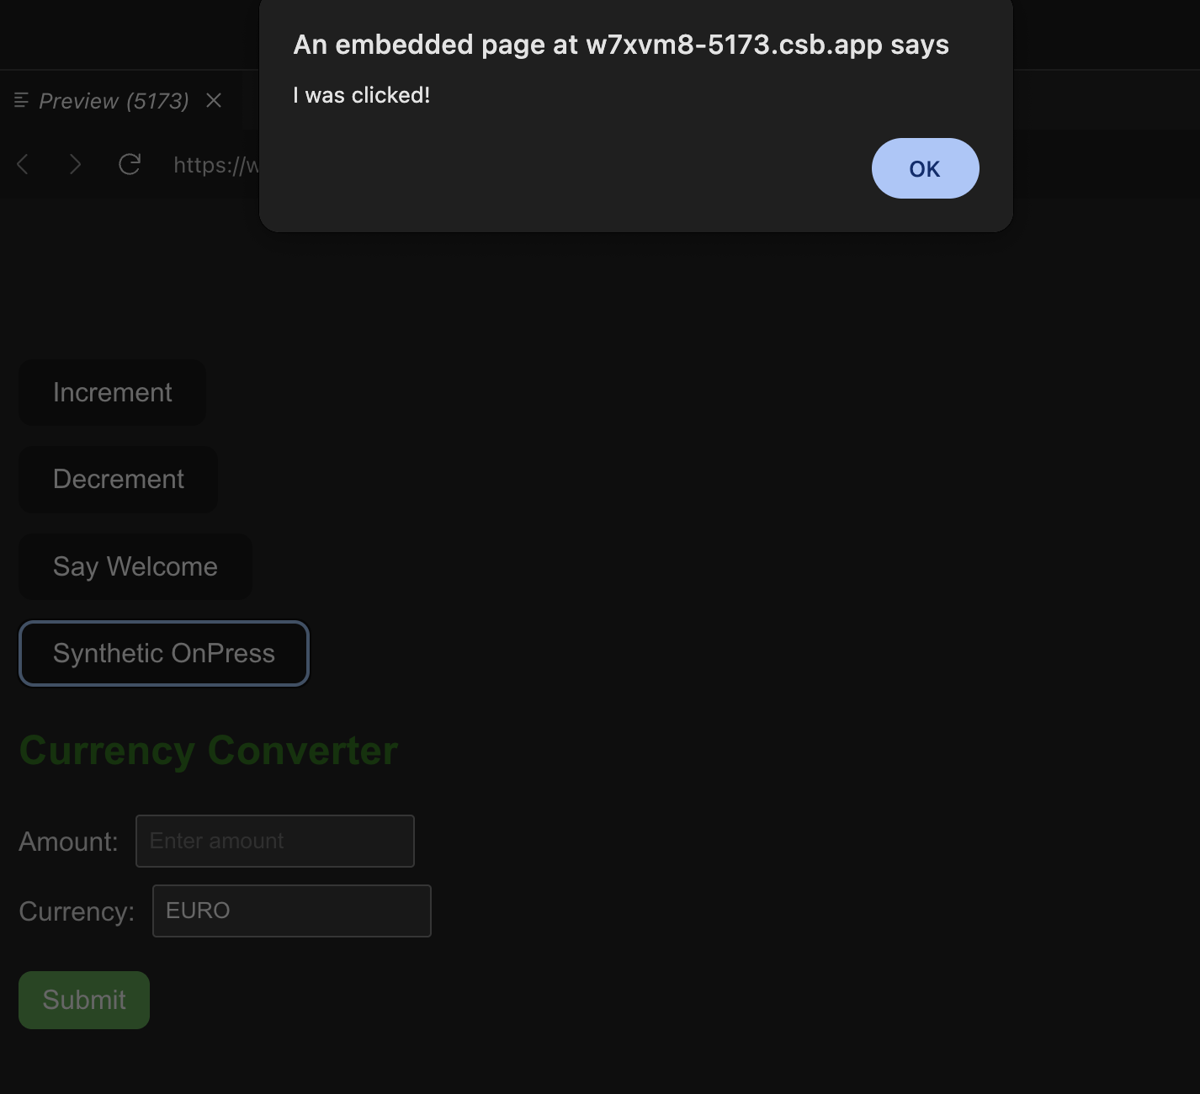

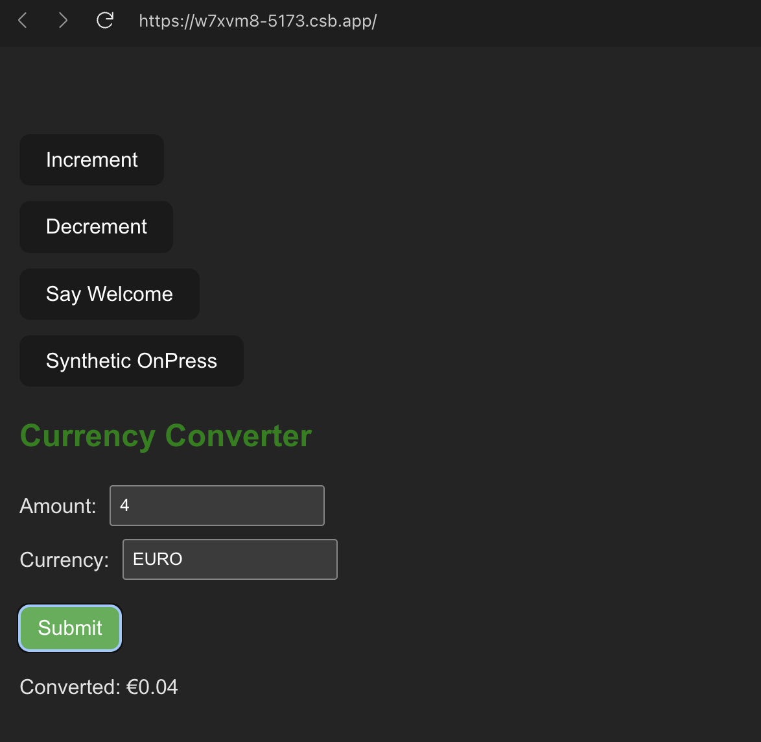

**Hands-On 12**

App.jsx:

import React, { Component } from "react";

function UserGreeting() {

return <h1>Welcome back!</h1>;

}

function GuestGreeting() {

return <h1>Please sign up.</h1>;

}

function Greeting(props) {

const isLoggedIn = props.isLoggedIn;

if (isLoggedIn) {

return <UserGreeting />;

}

return <GuestGreeting />;

}

function LoginButton(props) {

return <button onClick={props.onClick}>Login</button>;

}

function LogoutButton(props) {

return <button onClick={props.onClick}>Logout</button>;

}

class App extends Component {

constructor(props) {

super(props);

this.state = { isLoggedIn: false };

}

handleLoginClick = () => {

this.setState({ isLoggedIn: true });

};

handleLogoutClick = () => {

this.setState({ isLoggedIn: false });

};

render() {

const isLoggedIn = this.state.isLoggedIn;

let button;

if (isLoggedIn) {

button = <LogoutButton onClick={this.handleLogoutClick} />;

} else {

button = <LoginButton onClick={this.handleLoginClick} />;

}

return (

<div style={{ textAlign: "center", marginTop: "100px" }}>

<Greeting isLoggedIn={isLoggedIn} />

{button}

</div>

);

}

}

export default App;

**App.css:**

.App {

font-family: Arial, sans-serif;

padding: 20px;

max-width: 600px;

margin: auto;

}

h1 {

text-align: center;

color: #2c3e50;

}

.flight-section {

margin-top: 20px;

padding: 10px;

background-color: #f3f3f3;

border-radius: 6px;

}

.booking-form {

margin-top: 20px;

display: flex;

flex-direction: column;

gap: 10px;

}

.booking-form select,

.booking-form button {

padding: 8px;

font-size: 16px;

width: fit-content;

}

.auth-button {

margin-top: 20px;

}

**Output:**

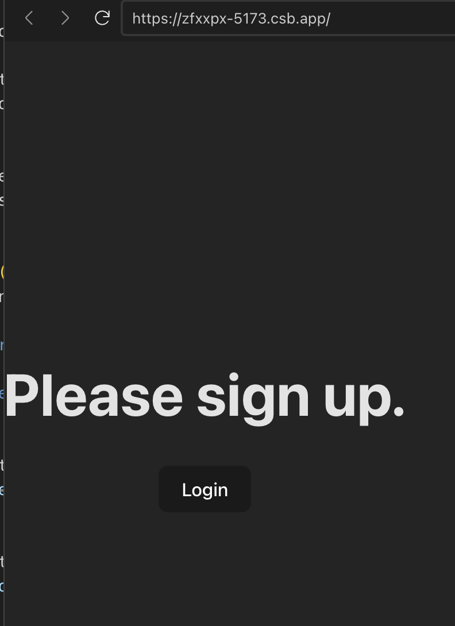

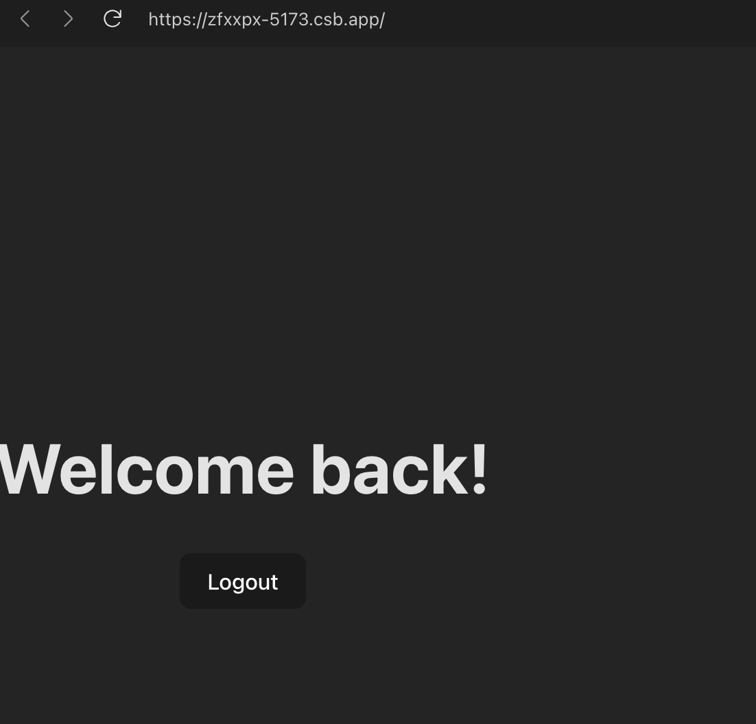

**Hands-On 13**

**App.jsx:**

import React from "react";

import BookDetails from "./BookDetails";

import BlogDetails from "./BlogDetails";

import CourseDetails from "./CourseDetails";

import "./index.css";

function App() {

return (

<div className="container">

<div className="box">

<CourseDetails />

</div>

<div className="box green-border">

<BookDetails />

</div>

<div className="box">

<BlogDetails />

</div>

</div>

);

}

export default App;

**Index.css:**

body {

font-family: sans-serif;

padding: 20px;

}

.container {

display: flex;

justify-content: space-between;

}

.box {

width: 30%;

padding: 20px;

}

.green-border {

border-left: 3px solid green;

border-right: 3px solid green;

}

h2 {

font-weight: bold;

}

main.jsx:

import React from "react";

import ReactDOM from "react-dom/client";

import App from "./App";

const root = ReactDOM.createRoot(document.getElementById("root"));

root.render(<App />);

BlogDetails.jsx:

import React from "react";

import { blogs } from "./data";

function BlogDetails() {

return (

<div>

<h2>Blog Details</h2>

{blogs.map((blog) => (

<div key={blog.id}>

<h3>{blog.title}</h3>

<strong>{blog.author}</strong>

<p>{blog.content}</p>

</div>

))}

</div>

);

}

export default BlogDetails;

**BookDetails.jsx:**

import React from "react";

import { books } from "./data";

function BookDetails() {

return (

<div>

<h2>Book Details</h2>

<ul>

{books.map((book) => (

<li key={book.id}>

<h3>{book.bname}</h3>

<h4>{book.price}</h4>

</li>

))}

</ul>

</div>

);

}

export default BookDetails;

**CourseDetails.jsx:**

import React from "react";

import { courses } from "./data";

function CourseDetails() {

return (

<div>

<h2>Course Details</h2>

{courses.map((course) => (

<div key={course.id}>

<h3>{course.name}</h3>

<p>{course.date}</p>

</div>

))}

</div>

);

}

export default CourseDetails;

**data.jsx:**

export const books = [

{ id: 101, bname: "Master React", price: 670 },

{ id: 102, bname: "Deep Dive into Angular 11", price: 800 },

{ id: 103, bname: "Mongo Essentials", price: 450 },

];

export const blogs = [

{

id: 1,

title: "React Learning",

author: "Stephen Biz",

content: "Welcome to learning React!",

},

{

id: 2,

title: "Installation",

author: "Schwezdneier",

content: "You can install React from npm.",

},

];

export const courses = [

{ id: 1, name: "Angular", date: "4/5/2021" },

{ id: 2, name: "React", date: "6/3/20201" },

];

**Output:**

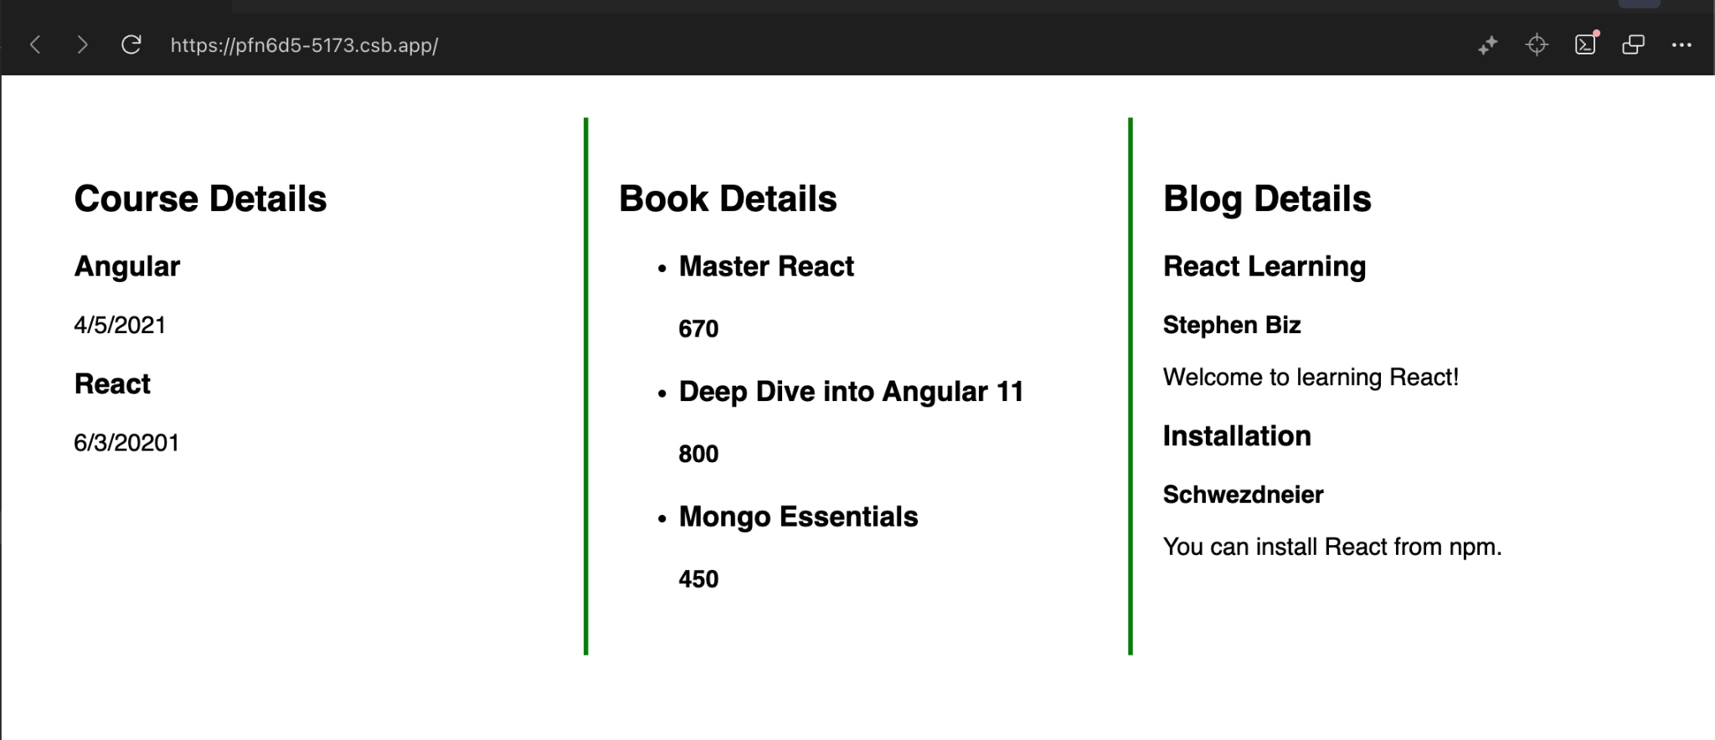

**Hands-On 14**

**EmployeeCard.jsx:**

import React, { useContext } from "react";

import ThemeContext from "./ThemeContext";

function EmployeeCard({ employee }) {

const theme = useContext(ThemeContext);

const buttonStyle = theme === "dark" ? "btn btn-dark" : "btn btn-light";

return (

<div className="card">

<h3>{employee.name}</h3>

<p>{employee.designation}</p>

<button className={buttonStyle}>View</button>

</div>

);

}

export default EmployeeCard;

**EmployeeList.jsx:**

import React from "react";

import EmployeeCard from "./EmployeeCard";

function EmployeeList() {

const employees = [

{ id: 1, name: "Alice", designation: "Developer" },

{ id: 2, name: "Bob", designation: "Tester" },

];

return (

<div>

<h2>Employee List</h2>

{employees.map((emp) => (

<EmployeeCard key={emp.id} employee={emp} />

))}

</div>

);

}

export default EmployeeList;

**App.jsx:**

import React, { useState } from "react";

import EmployeeList from "./EmployeeList";

import ThemeContext from "./ThemeContext";

function App() {

const [theme, setTheme] = useState("light");

const toggleTheme = () =>

setTheme((prevTheme) => (prevTheme === "light" ? "dark" : "light"));

return (

<ThemeContext.Provider value={theme}>

<div className="App">

<h1>Employee Management</h1>

<button onClick={toggleTheme}>Toggle Theme (Current: {theme})</button>

<EmployeeList />

</div>

</ThemeContext.Provider>

);

}

export default App;

**ThemeContext.jsx:**

import React from "react";

const ThemeContext = React.createContext("light");

export default ThemeContext;

**App.css:**

#root {

max-width: 1280px;

margin: 0 auto;

padding: 2rem;

text-align: center;

}

.btn-light {

background-color: white;

color: black;

padding: 6px 12px;

border: 1px solid #ccc;

}

.btn-dark {

background-color: black;

color: white;

padding: 6px 12px;

border: 1px solid #ccc;

}

.logo {

height: 6em;

padding: 1.5em;

will-change: filter;

transition: filter 300ms;

}

.logo:hover {

filter: drop-shadow(0 0 2em #646cffaa);

}

.logo.react:hover {

filter: drop-shadow(0 0 2em #61dafbaa);

}

@keyframes logo-spin {

from {

transform: rotate(0deg);

}

to {

transform: rotate(360deg);

}

}

@media (prefers-reduced-motion: no-preference) {

a:nth-of-type(2) .logo {

animation: logo-spin infinite 20s linear;

}

}

.card {

padding: 2em;

}

.read-the-docs {

color: #888;

}

**Output:**

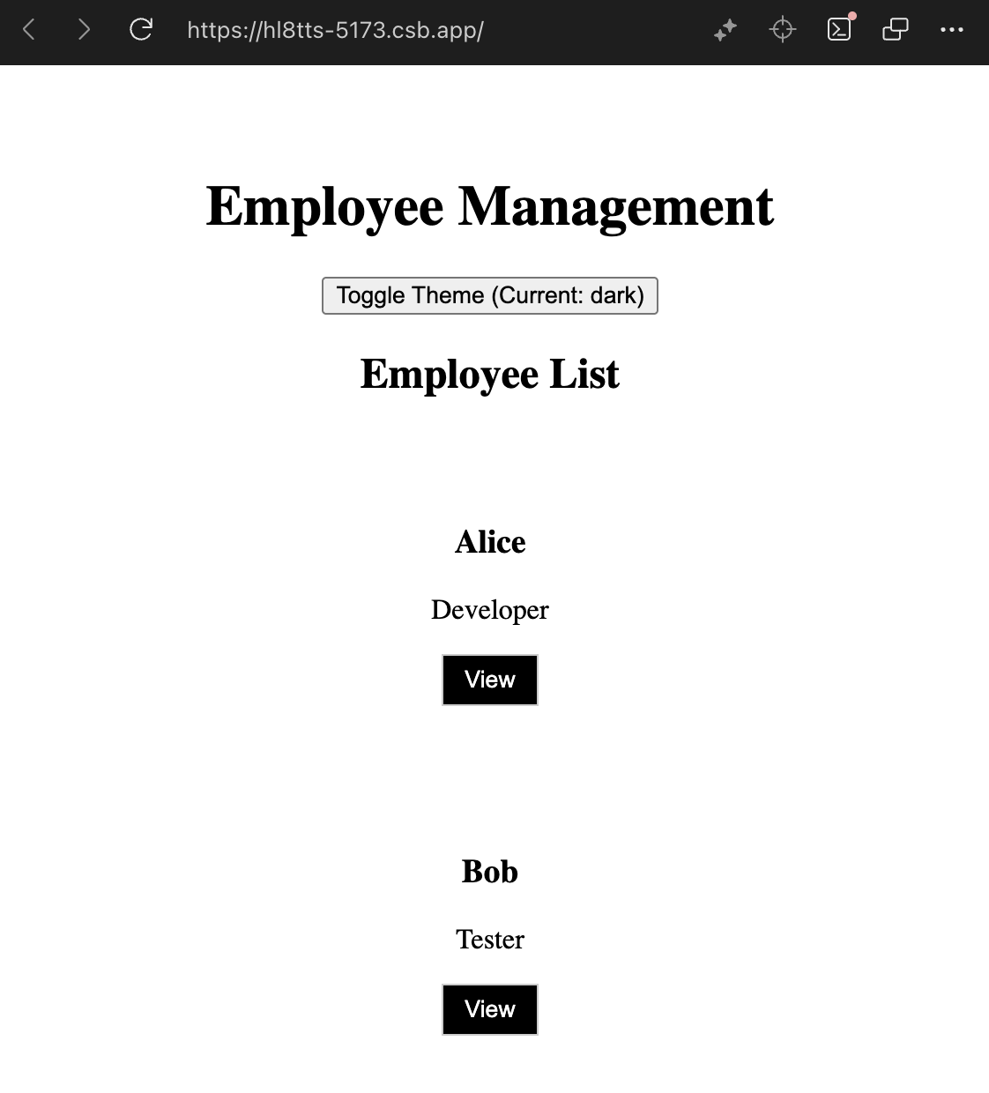

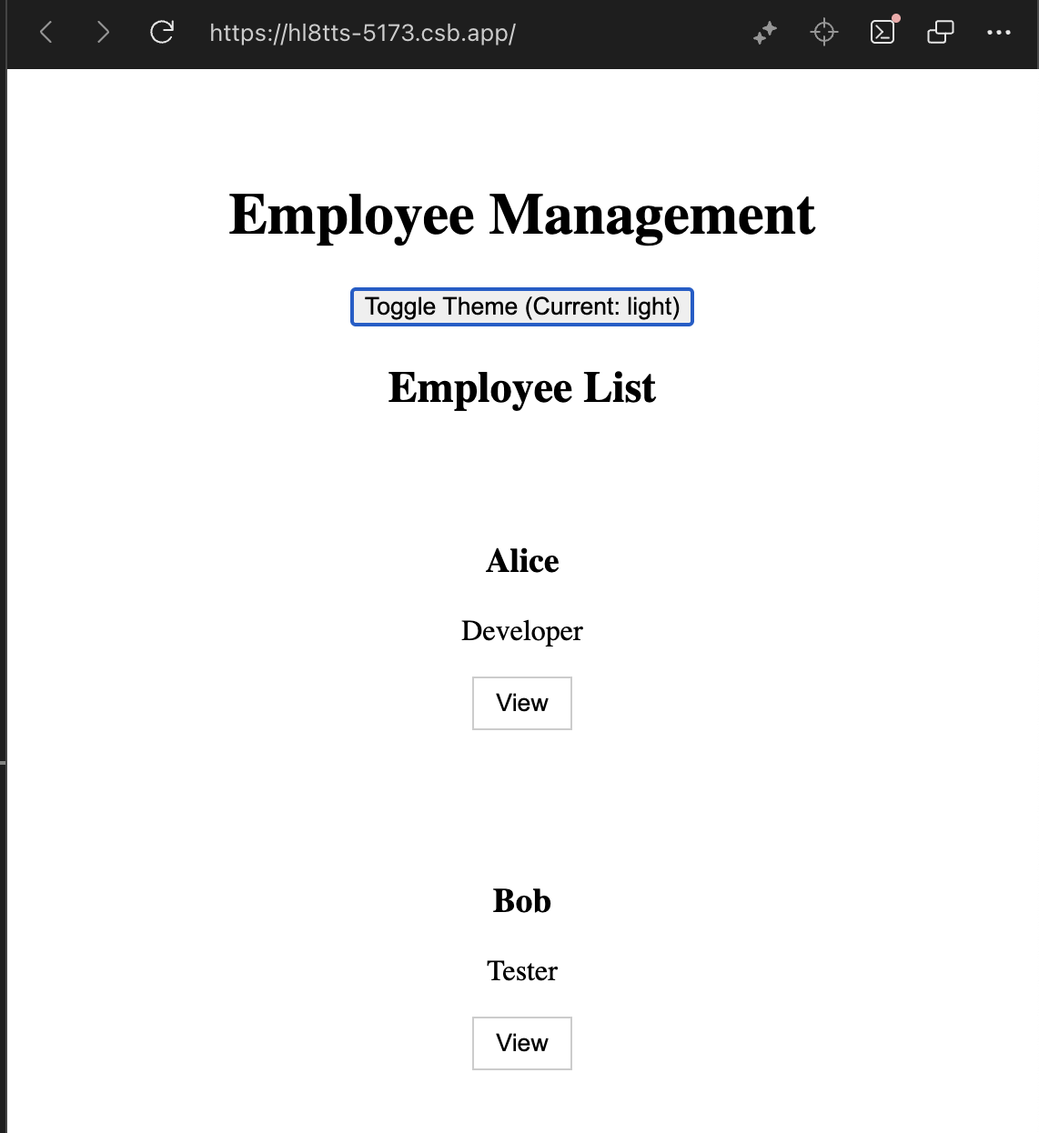

**Hands-On 15**

**App.jsx:**

import React from "react";

import ComplaintRegister from "./ComplaintRegister";

function App() {

return (

<div className="App">

<ComplaintRegister />

</div>

);

}

export default App;

**ComplaintRegister.jsx:**

import React, { Component } from "react";

class ComplaintRegister extends Component {

constructor(props) {

super(props);

this.state = {

ename: "",

complaint: "",

NumberHolder: Math.floor(Math.random() * 100) + 1,

};

}

handleChange = (event) => {

this.setState({ [event.target.name]: event.target.value });

};

handleSubmit = (event) => {

event.preventDefault();

const msg =

"Thanks " +

this.state.ename +

"\nYour Complaint was Submitted.\nTransaction ID is: " +

this.state.NumberHolder;

alert(msg);

this.setState({

ename: "",

complaint: "",

NumberHolder: Math.floor(Math.random() * 100) + 1,

});

};

render() {

return (

<div style={{ textAlign: "center", marginTop: "50px" }}>

<h2 style={{ color: "red" }}>Register your complaints here!!!</h2>

<form onSubmit={this.handleSubmit}>

<div>

<label>Name:&nbsp;</label>

<input

type="text"

name="ename"

value={this.state.ename}

onChange={this.handleChange}

/>

</div>

<br />

<div>

<label>Complaint:&nbsp;</label>

<textarea

name="complaint"

value={this.state.complaint}

onChange={this.handleChange}

/>

</div>

<br />

<button type="submit">Submit</button>

</form>

</div>

);

}

}

export default ComplaintRegister;

Output:

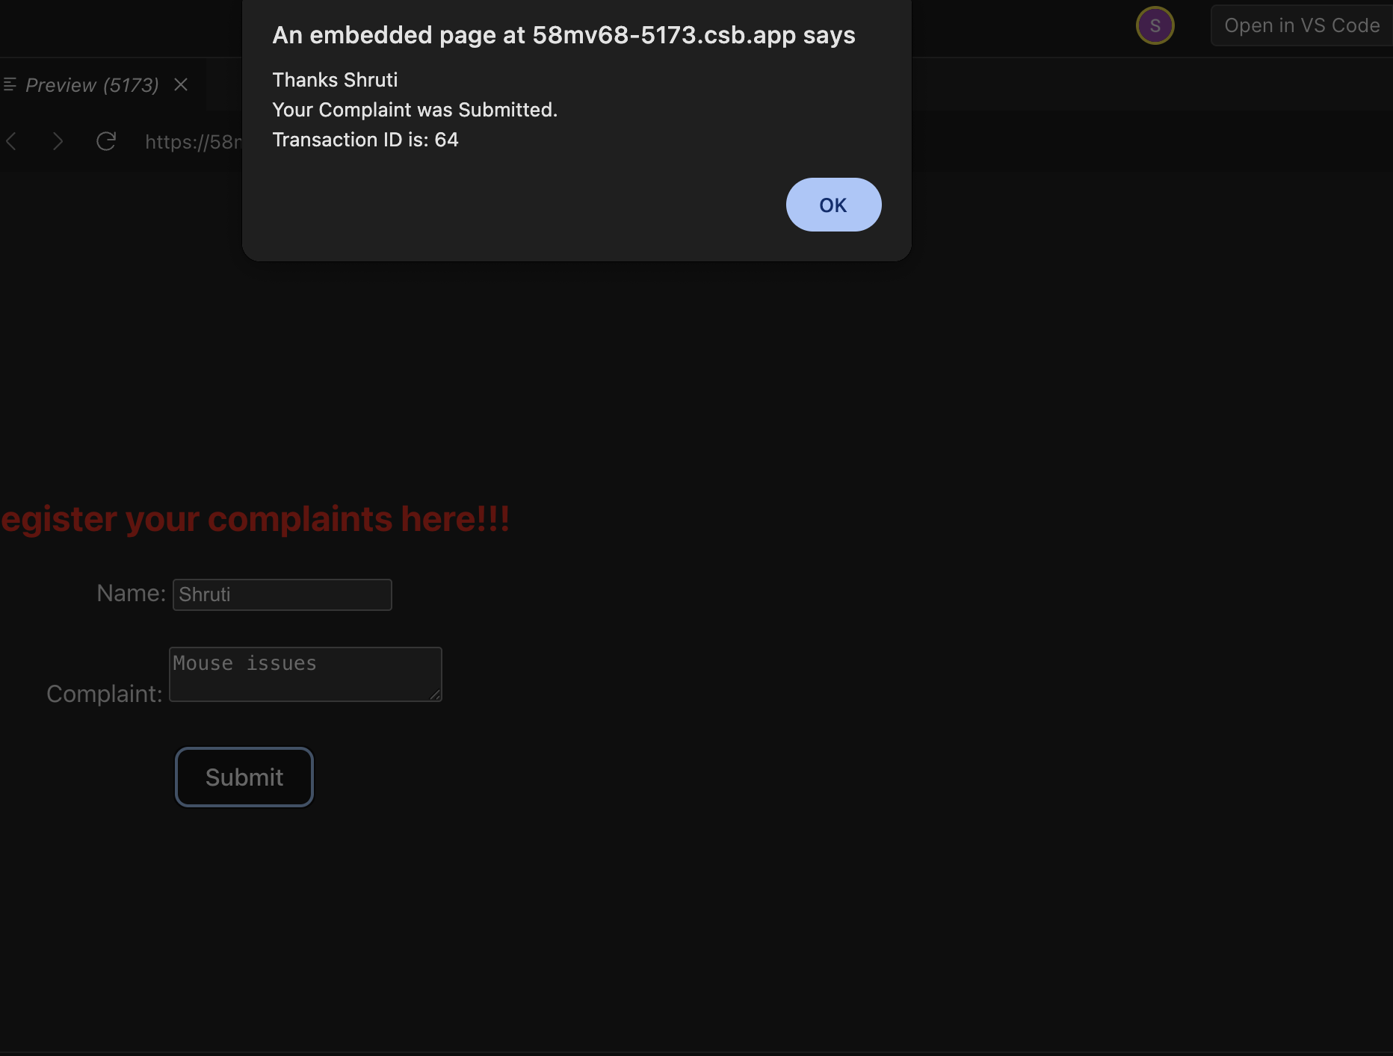

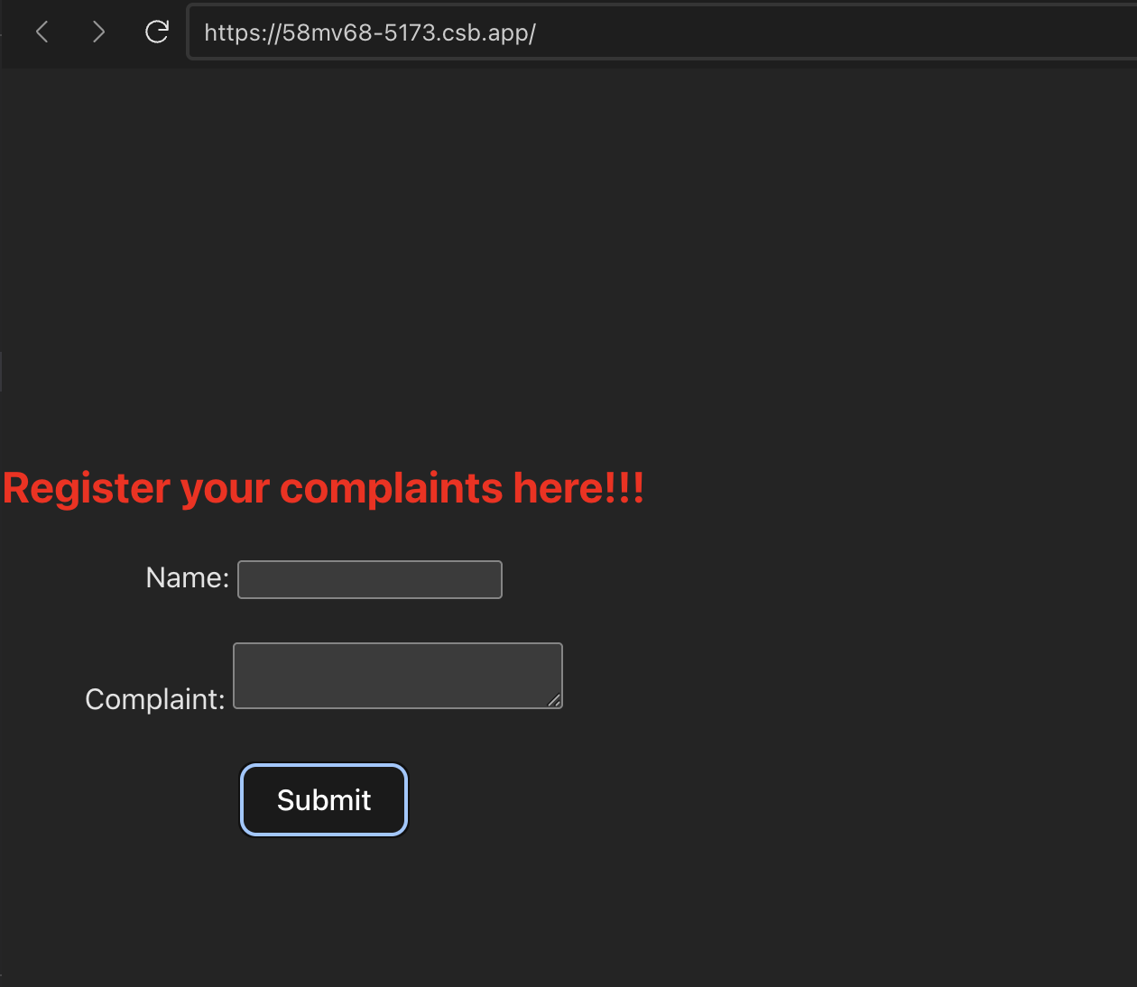

**Hands-On 16**

App.jsx:

import React from "react";

import Register from "./register";

function App() {

return <Register />;

}

export default App;

Register.jsx:

import React, { Component } from "react";

class Register extends Component {

constructor(props) {

super(props);

this.state = {

fullName: "",

email: "",

password: "",

errors: {

fullName: "",

email: "",

password: "",

},

};

}

validateForm = (errors) => {

return !Object.values(errors).some((error) => error.length > 0);

};

handleChange = (event) => {

const { name, value } = event.target;

let errors = this.state.errors;

switch (name) {

case "fullName":

errors.fullName =

value.length < 5

? "Full Name must be at least 5 characters long!"

: "";

break;

case "email":

const validEmailRegex = RegExp(/^[^\s@]+@[^\s@]+\.[^\s@]+$/);

errors.email = validEmailRegex.test(value) ? "" : "Email is not valid!";

break;

case "password":

errors.password =

value.length < 8 ? "Password must be 8 characters long!" : "";

break;

default:

break;

}

this.setState({ errors, [name]: value });

};

handleSubmit = (event) => {

event.preventDefault();

if (this.validateForm(this.state.errors)) {

alert("Valid Form");

} else {

const { errors } = this.state;

if (errors.fullName) alert(errors.fullName);

if (errors.email) alert(errors.email);

if (errors.password) alert(errors.password);

}

};

render() {

const { errors } = this.state;

return (

<div style={{ textAlign: "center", marginTop: "30px" }}>

<h1 style={{ color: "red" }}>Register Here!!!</h1>

<form onSubmit={this.handleSubmit}>

<div>

<label>Name: </label>

<input type="text" name="fullName" onChange={this.handleChange} />

</div>

<br />

<div>

<label>Email: </label>

<input type="text" name="email" onChange={this.handleChange} />

</div>

<br />

<div>

<label>Password: </label>

<input

type="password"

name="password"

onChange={this.handleChange}

/>

</div>

<br />

<button type="submit">Submit</button>

</form>

</div>

);

}

}

export default Register;

**Output**:

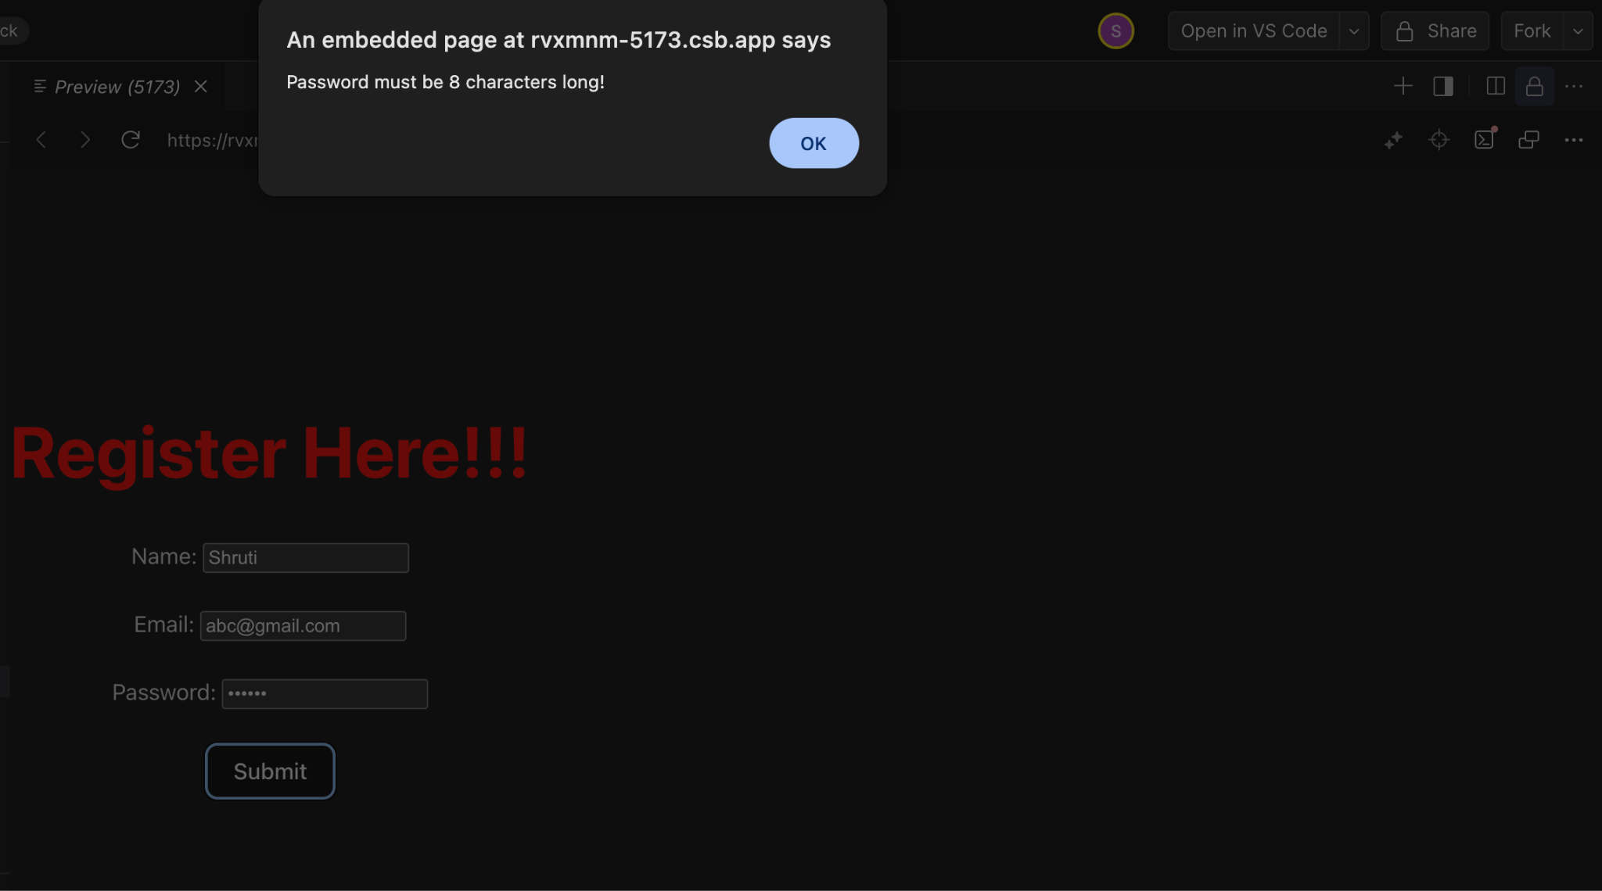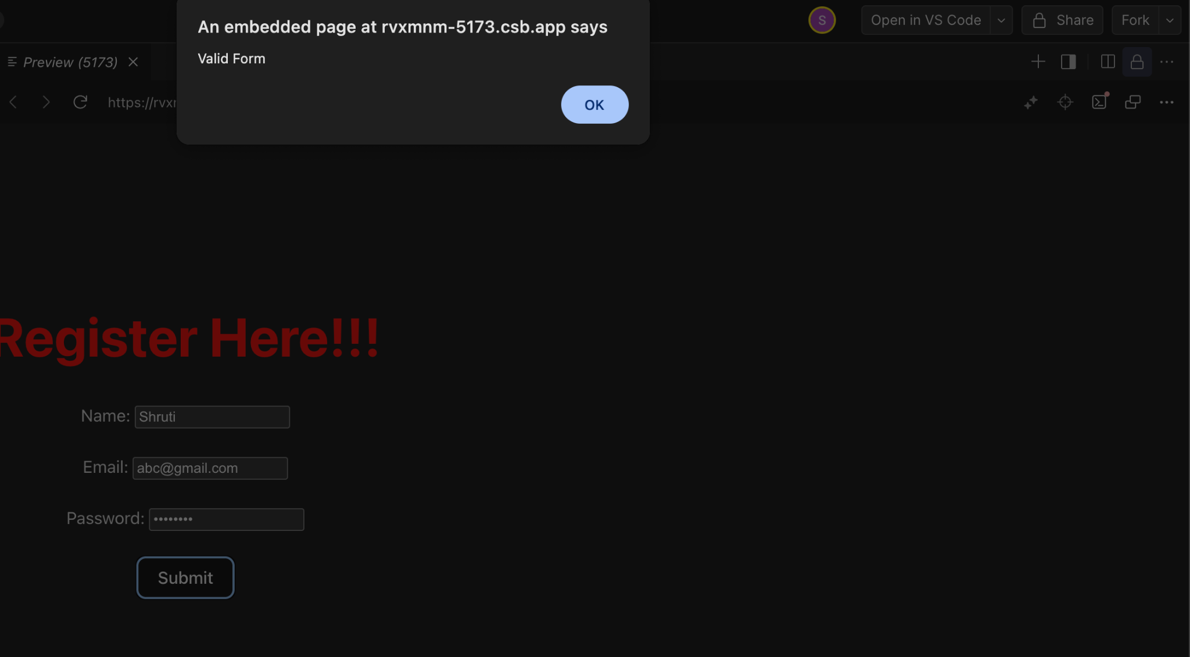

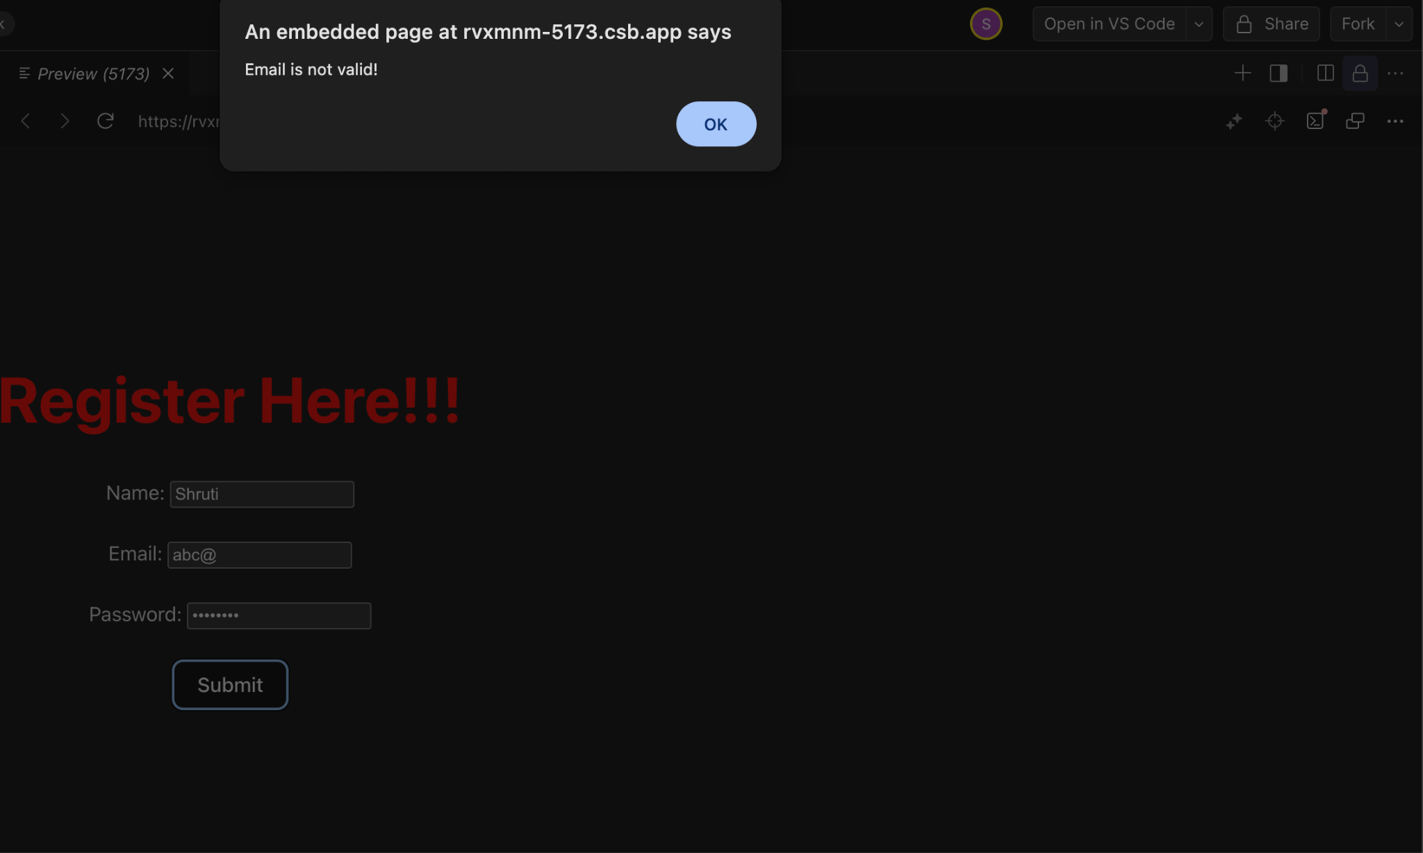

**Hands-On 17**

**App.jsx:**

import React from "react";

import Getuser from "./Getuser";

function App() {

return (

<div className="App">

<Getuser />

</div>

);

}

export default App;

Getuser.jsx:

import React, { Component } from "react";

class Getuser extends Component {

constructor(props) {

super(props);

this.state = {

person: null,

loading: true,

};

}

async componentDidMount() {

const url = "https://api.randomuser.me/";

const response = await fetch(url);

const data = await response.json();

this.setState({

person: data.results[0],

loading: false,

});

console.log(data.results[0]);

}

render() {

const { person, loading } = this.state;

if (loading) {

return <h2>Loading...</h2>;

}

return (

<div style={{ textAlign: "center", marginTop: "50px" }}>

<h1>

{person.name.title} {person.name.first} {person.name.last}

</h1>

<img src={person.picture.medium} alt="User" />

</div>

);

}

}

export default Getuser;

**Output:**

